**SMART PUBLIC RESTROOMS**

**Sensors**:

* IR Sensors
* Occupancy Sensors
* Proximity Sensors
* Water flow sensors
* Motion Sensors
* Air Quality Sensors
* Temperature Sensors

**Datasets:**

Usage Data: Collect data on restroom usage, including the number of visitors, peak usage times, and average visit duration. This can help in optimizing cleaning schedules and resource allocation

Environmental Data: Gather data on temperature, humidity, and air quality within the restroom. This can be used to control heating, ventilation, and air conditioning (HVAC) systems for comfort and energy efficiency

Occupancy Sensing Data: Implement occupancy sensors to detect when restroom stalls are in use. This data helps in providing real-time information about stall availability and can be useful for crowd management.

Toilet Paper and Soap Dispenser Data: Install sensors on toilet paper and soap dispensers to monitor usage and refill requirements. This helps in efficient maintenance and avoids running out of essential supplies.

Cleaning and Maintenance Records: Keep a digital record of cleaning and maintenance activities, including when cleaning was last performed, what products were used, and any issues that were resolved

Feedback and Ratings: Allow users to provide feedback on the cleanliness and functionality of the restroom. Analyze this data to improve the overall restroom experience.

Water Usage Data: Monitor water usage in sinks and flushes to identify water-saving opportunities and detect leaks

Energy Consumption Data: Track energy consumption of lighting, HVAC, and other electrical systems to optimize energy usage.

Security Camera Footage: Install security cameras to monitor security and safety within the restroom area. Ensure privacy and data protection measures are in place.

User Behavior Analytics: Analyze user behavior, such as traffic flow within the restroom and user preferences, to optimize restroom design and resource allocation.

Inventory and Supplier Data: Keep track of inventory levels for restroom supplies (toilet paper, soap, etc.) and establish data connections with suppliers for automated restocking

Local Events and Calendar Data: Incorporate local events and public calendar data to predict rooms.

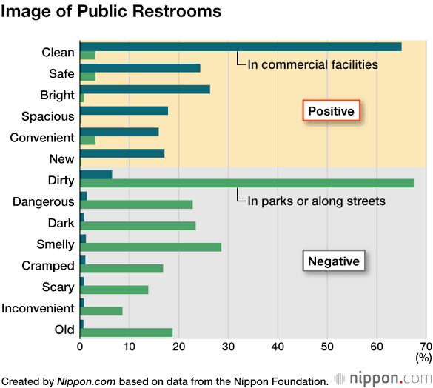

**MODEL RESULT:**

Automated Cleaning: Implement sensors and robotics to monitor restroom cleanliness and initiate cleaning when needed.

Occupancy Monitoring: Use occupancy sensors to track restroom usage and display real-time occupancy information for users.

Water and Energy Efficiency: Incorporate low-flow fixtures and energy-efficient lighting to reduce resource consumption.

Touchless Fixtures: Install touchless faucets, soap dispensers, and flush systems to minimize germ transmission.

Smart Maintenance: Implement predictive maintenance systems to monitor restroom equipment and ensure timely repairs.

User Feedback: Collect feedback through mobile apps or kiosks to improve restroom conditions and service.

Accessibility Features: Ensure ADA compliance with features like grab bars, accessible sinks, and changing stations.

Hygiene Stations: Offer hand sanitizing stations and hygiene supplies within the restroom.

Security: Use security cameras and alarms for user safety.

Real-time Updates: Enable users to check restroom availability and conditions via a mobile app or website.

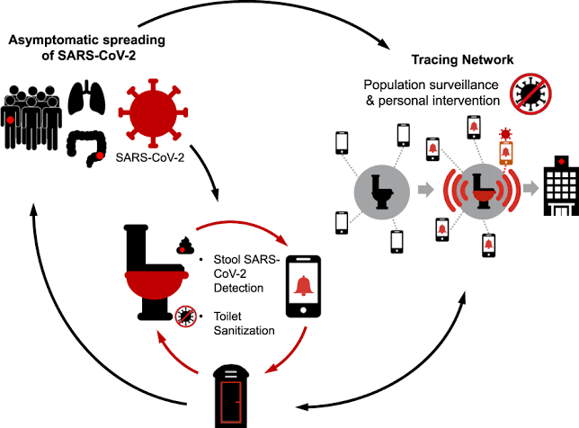

A system image is a comprehensive and exact duplicate of an entire computer's operating system, including the operating system itself, system files, installed applications, user data, and system configurations.

**TABULATION:**

In this example, we have various parameters and their corresponding readings. These readings represent data collected from different sensors or measurements in a given environment or system.

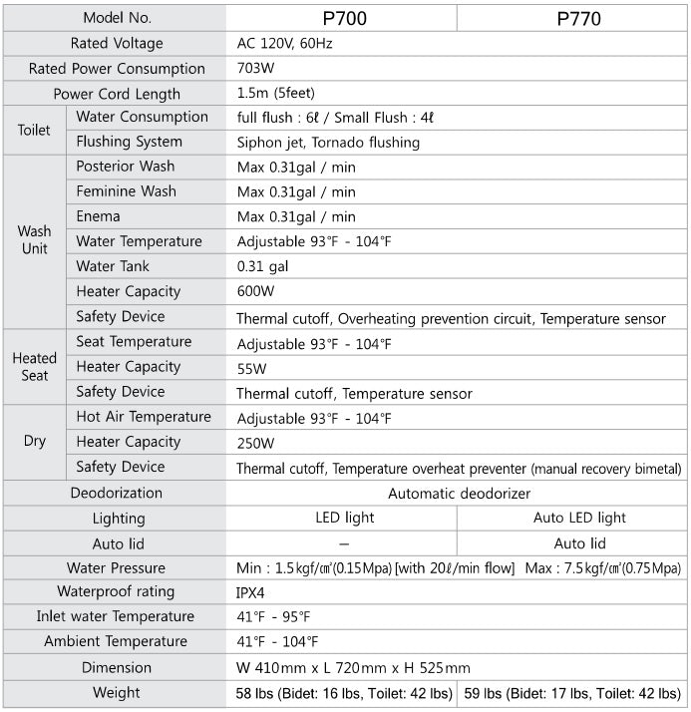

Smart Public Restroom using the Wokwi simulator. Wokwi is a platform for simulating and prototyping electronic circuits and microcontroller projects. In this example, we’ll create a simple simulation of a smart public restroom that monitors the occupancy and provides feedback through an LED.

Components you’ll need:

1. Arduino board (e.g., Arduino Uno).
2. An LED to simulate the restroom occupancy indicator.
3. A push-button to simulate the restroom door.

Step 1: Sign up and log in to Wokwi

If you haven’t already, sign up for a Wokwi account and log in to the platform.

Step 2: Create a New Project

1. Click on “Create a Project” to start a new project.
2. Choose the Arduino board you want to use (e.g., “Arduino Uno”).
3. Name your project (e.g., “SmartRestroomSimulation”).
4. Click “Create.”

Step 3: Add Components to the Project

1. On the project canvas, you’ll see the Arduino board.
2. Search for “LED” in the component search bar and drag an LED component onto the canvas.
3. Search for “Push Button” and add it to the canvas.

Step 4: Connect Components

1. Connect one leg of the LED to a digital pin on the Arduino (e.g., Pin 2).
2. Connect the other leg of the LED to a current-limiting resistor (e.g., 220-330 Ohms).
3. Connect the other end of the resistor to the GND (ground) on the Arduino.
4. Connect one leg of the push button to a digital pin on the Arduino (e.g., Pin 7).
5. Connect the other leg of the push button to the GND (ground) on the Arduino.

Step 5: Write Arduino Code

Now, you’ll need to write the Arduino code to control the LED based on the state of the push button.

#include <Servo.h>

Const int buttonPin = 7;

Const int ledPin = 2;

Const int servoPin = 9; // Digital pin for the servo

Int buttonState = 0;

Servo doorServo;

Void setup() {

pinMode(ledPin, OUTPUT);

pinMode(buttonPin, INPUT);

doorServo.attach(servoPin); // Attaching the servo to the pin

}

Void loop() {

buttonState = digitalRead(buttonPin);

if (buttonState == HIGH) {

// Restroom is occupied

digitalWrite(ledPin, HIGH);

// Open the door (rotate the servo)

doorServo.write(90); // Angle to open the door

} else {

// Restroom is vacant

digitalWrite(ledPin, LOW);

// Close the door (return the servo to its initial position)

doorServo.write(0); // Angle to close the door

}

}

Step 6: Simulate the Project

1. Click on the “Simulate” button to start the simulation.
2. You can now interact with the simulation by pressing the push button and observing the LED’s behavior.

This simple example simulates a smart public restroom where the LED indicates the occupancy status based on the state of the push button. You can extend and customize this project by adding more features, such as an occupancy counter or a feedback mechanism. Wokwi provides a powerful And flexible environment for simulating and testing your electronic projects before implementing them in the physical world.